LAB 06
TASK 01:
select location_ID, street_address, city, state_province,country_name
from locations natural join countries ;

OUTPUT:
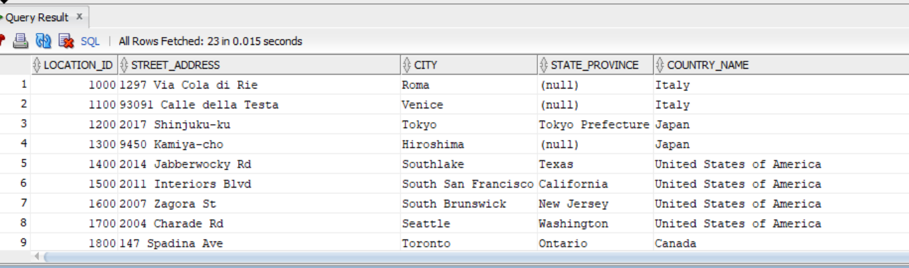
TASK 02
SELECT e.last_name, e.department_id, d.department_name
from employees e join departments d on(e.department_id= d.department_id)

OUTPUT:
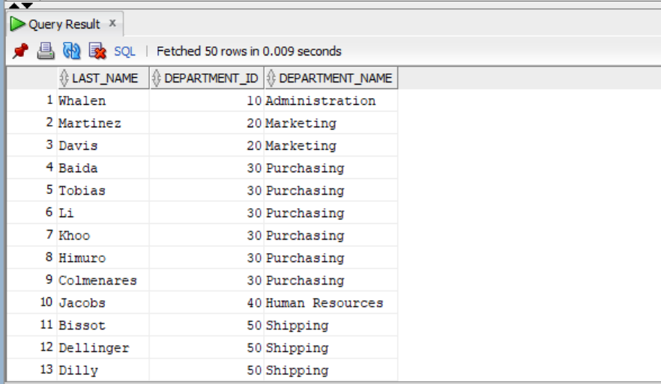
TASK 03
select e.*
from employees e
join departments d on e.department_id=d.department_id
join locations l on d.location_id=l.location_id
join countries c on l.country_id=c.country_id
join regions r on c.region_id=r.region_id
where d.department_name='Sales' and r.region_name ='Africa';

OUTPUT:
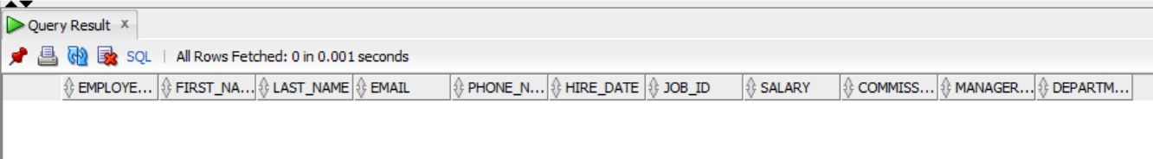

TASK 04
select d.department_name,( e.first_name||' '||e.last_name) as employees , l.city, m.first_name|| ' '||m.last_name as manager
from employees e
join departments d on (e.department_id=d.department_id)
join locations l on (l.location_id=l.location_id)
join employees m on(e.manager_id=e.manager_id);

OUTPUT:
